IT24104013

Manage M D N S

LabSheet 04

PS

1. And 2)

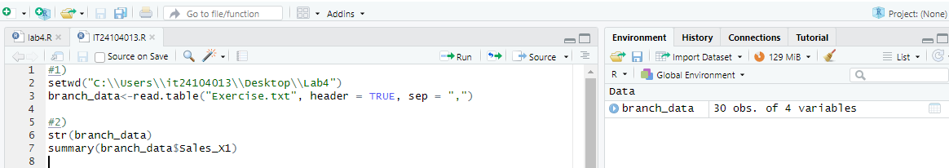

3)and 4)

5)

